# ***Challenge Name :- 𓂀Blindfolded***

**Description:** Introducing 'Blindfolded,' a challenge where perception is key. Delve into two layers of puzzles, where uncovering hidden vulnerabilities and mastering subtle challenges is your goal. Can you overcome the obstacles and claim victory.

**Level:** Medium

**Solution: :**

**Step 1:** You will see a login page do auth bypass with some auth bypass payload .

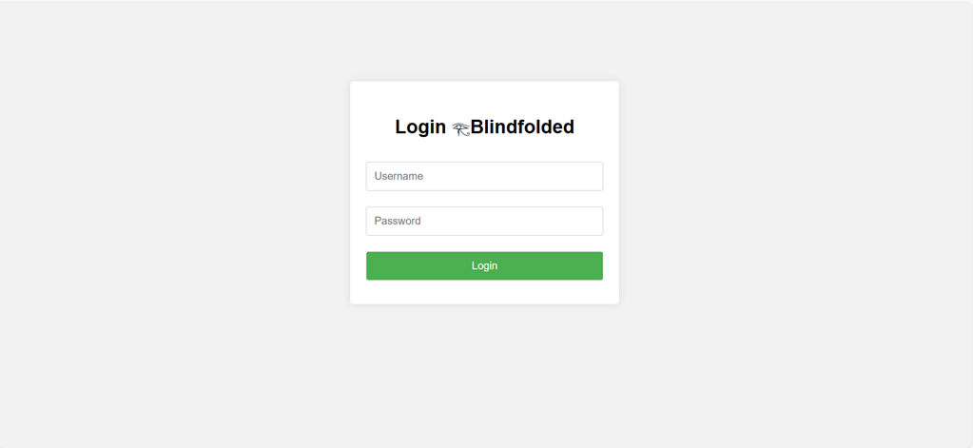

**Step-2:** You have to put sql payload .

**Username:** admin **Password:** "1"="1"/*

You will redirect to dashboard section .

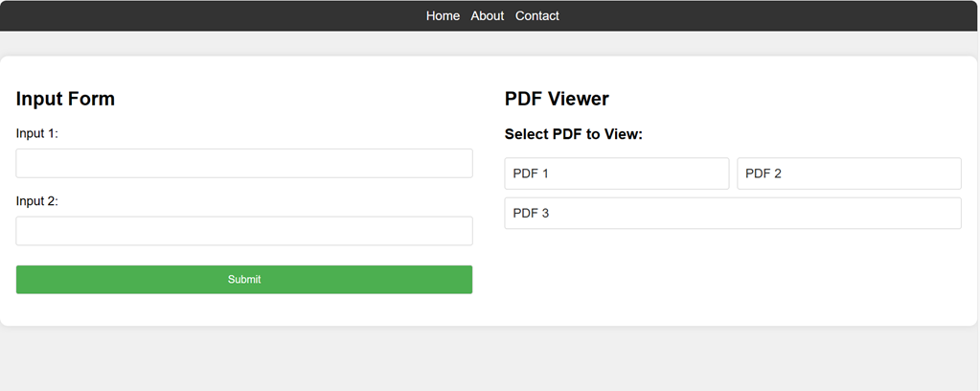

**Step-3:** Here some there vulnerability present . You will see two section one is input and other is pdf view When you try to see pdf 1 and 2 then at bottom you will see hint .

pdf1→ GO

Pdf2→ 9

Pdf3→9

It’s mean here is some pdf which have name pdf99 which have the flag.

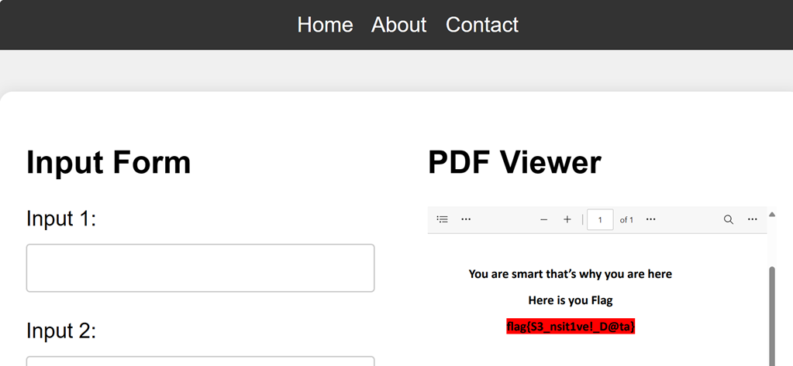

**Flag:** flag{S3_nsit1ve!_D@ta}

This page is intentionally left blank